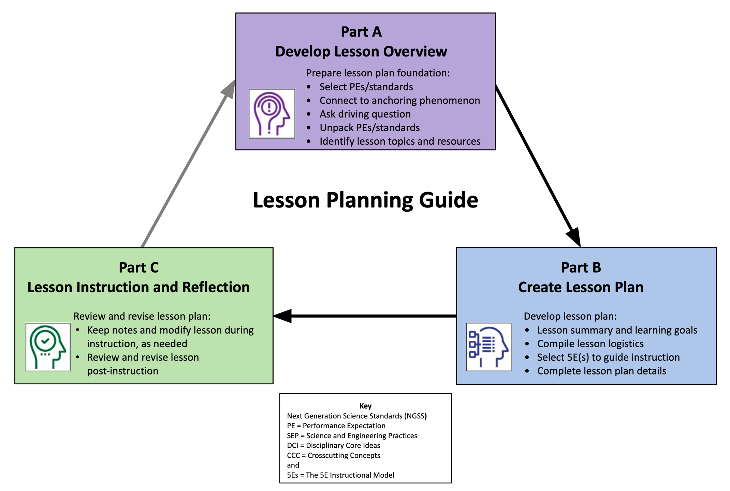

Lesson Planning Guide
Develop Lesson Plans for Instruction
Steps in developing NGSS-/standards-aligned, phenomenon-based lessons that are guided by the 5Es instructional model:
- Complete the Lesson Plan Overview (Part A) to guide development of lesson plans.
- Use the Lesson Plan Template (Part B) to create detailed lesson plans.

 | Lesson Overview Template (Part A)
1.a Select grade level NGSS Performance Expectations (PEs) or Topics, or district/state standards that support lesson-based student learning goals.
For NGSS, PE color coding reflects its 3-dimensional learning components. Search the Evidence Statements for details on what students should know and do.
High School 9-12

HS-PS2-1. Analyze data to support the claim that Newton’s second law of motion describes the mathematical relationship
among the net force on a macroscopic object, its mass, and its acceleration.

1.b Identify a lesson-based anchoring phenomenon that builds towards understanding of the PEs/standards, and is engaging and relevant to students.
See more about phenomena and using phenomena with NGSS.
River flow velocity and sediment particle size.
1.c Ask a Driving Question, which is authentic and student-focused, that relates to investigating the PEs/standards and phenomenon.
See more about Driving Questions and using Driving Questions with NGSS.
How does river flow velocity impact sediment particle size and what other variables have an influence on this?
1.d Unpack the 3-D learning components of the Performance Expectations/standards in the table below.
For NGSS guidance, see the NGSS Topic Arrangements and NGSS DCI Arrangements. Use tools to unpack each PE separately.
Science and Engineering Practices (SEP)  (skills) |  | Disciplinary Core Ideas (DCI)  (content) | Crosscutting Concepts (CCC)  (connections)
Planning and Carrying Out Investigations  Planning and carrying out investigations to answer questions or  test solutions to problems in 9–12 builds on K–8 experiences and  progresses to include investigations that provide evidence for and  test conceptual, mathematical, physical and empirical models.  ▪ Plan and conduct an investigation individually and  collaboratively to produce data to serve as the basis for  evidence, and in the design: decide on types, how much, and  accuracy of data needed to produce reliable measurements  and consider limitations on the precision of the data (e.g.,  number of trials, cost, risk, time), and refine the design  accordingly. (HS-PS2-5)  Analyzing and Interpreting Data  Analyzing data in 9–12 builds on K–8 and progresses to  introducing more detailed statistical analysis, the comparison of  data sets for consistency, and the use of models to generate and  analyze data.  ▪ Analyze data using tools, technologies, and/or models (e.g.,  computational, mathematical) in order to make valid and  reliable scientific claims or determine an optimal design  solution. (HS-PS2-1)  Using Mathematics and Computational Thinking  Mathematical and computational thinking at the 9–12 level builds  on K–8 and progresses to using algebraic thinking and analysis, a  range of linear and nonlinear functions including trigonometric  functions, exponentials and logarithms, and computational tools  for statistical analysis to analyze, represent, and model data.  Simple computational simulations are created and used based on  mathematical models of basic assumptions.  ▪ Use mathematical representations of phenomena to describe  explanations. (HS-PS2-2),(HS-PS2-4)  Constructing Explanations and Designing Solutions  Constructing explanations and designing solutions in 9–12 builds  on K–8 experiences and progresses to explanations and designs  that are supported by multiple and independent student-generated  sources of evidence consistent with scientific ideas,  principles, and theories.  ▪ Apply scientific ideas to solve a design problem, taking into  account possible unanticipated effects. (HS-PS2-3) |  | PS2.A: Forces and Motion  ▪ Newton’s second law accurately predicts changes in the motion  of macroscopic objects. (HS-PS2-1)  ▪ Momentum is defined for a particular frame of reference; it is  the mass times the velocity of the object. (HS-PS2-2)  ▪ If a system interacts with objects outside itself, the total  momentum of the system can change; however, any such  change is balanced by changes in the momentum of objects  outside the system. (HS-PS2-2),(HS-PS2-3) | Patterns  ▪ Different patterns may be observed  at each of the scales at which a  system is studied and can provide  evidence for causality in explanations  of phenomena. (HS-PS2-4)  Cause and Effect  ▪ Empirical evidence is required to  differentiate between cause and  correlation and make claims about  specific causes and effects. (HS-PS2-  1),(HS-PS2-5)  ▪ Systems can be designed to cause a  desired effect. (HS-PS2-3)

1.e Determine students’ prior knowledge about the lesson concepts. (e.g., pre-test, class discussion, exit ticket, 1-minute report, KWL chart, survey, etc.)
Class discussion on graph interpretation, velocity review, and sediment particle size.

1.f Identify Lesson Topics and Learning Goals: List main lesson concepts related to grade level PEs/standards that support student learning goals in figuring out the anchoring phenomenon; revise as needed.
Topics:
Velocity / river flow velocity
Velocity’s influence on erosional processes
Velocity’s influence on sedimentation processes

Learning Goals: Students will be able to explain the claim of Newton’s second law of motion describes the mathematical relationship
among the net force on a macroscopic object, its mass, and its velocity, using data including a graph of velocity as a function of particle size for objects subject to a net unbalanced force of flowing water, and mathematical equations.
Students will be able apply their understanding of velocity to examine and explain natural processes.

1.g Select Lesson Resources: Identify resources to develop lessons that address the PEs/standards and investigate the anchoring phenomenon through a variety of sequenced activities; revise as needed (include title and URL).
Stream Sediments: https://www4.uwsp.edu/geo/faculty/lemke/geomorphology/lectures/03_stream_sediment.html

USGS, Texas Water Dashboard: https://txpub.usgs.gov/txwaterdashboard/index.html
NOAA-National Weather Service-National Observations: https://water.weather.gov/ahps/
Science-Physics-Fluid: How to calculate flow rates: https://sciencing.com/definition-of-hydraulic-pneumatic-systems-13637116.html

 | Lesson Plan Template (Part B)
Grade and Subject | Physics |  |  |  | Instructional Time  (min.) | 2 days
Lesson Title (Topic) | Velocity
Anchoring Phenomenon  (copy from 1.b) | River flow velocity and sediment particle size.
Driving Question  (copy from 1.c) | How does river flow velocity impact sediment particle size and what other variables have an influence on this?
Lesson Overview
Lesson Summary  (description) |  |  | Lesson Topics and Student Learning Goals  (copy from 1.f)
River Flow Velocity and Sediment Particle Size Lesson  Students will be introduced to the basic relationship of river flow velocity and particle size using a Filip Hjulström Graph. Using that graph and different physics equations, students will solve for river area, river flow velocities, and expected particle size under the settling velocity curve. The students will then calculate different variables based on a given situation to gain further understanding of the relationship of velocity and sediment particle size. |  |  | Topics:  Velocity / river flow velocity  Velocity’s influence on erosional processes  Velocity’s influence on sedimentation processes  Learning Goals: Students will be able to explain the claim of Newton’s second law of motion describes the mathematical relationship  among the net force on a macroscopic object, its mass, and its velocity, using data including a graph of velocity as a function of particle size for objects subject to a net unbalanced force of flowing water, and mathematical equations.  Students will be able apply their understanding of velocity to examine and explain natural processes.
Lesson Resources Aligned with Standards
Lesson Resource  (copy from 1.g, sequenced with titles and links) |  |  | Resource Standards Alignment  (copy from 1.d, standards notated, link optional)
Science-Physics-Fluid: How to calculate flow rates: https://sciencing.com/definition-of-hydraulic-pneumatic-systems-13637116.html |  |  | HS-PS2-1.  HSA-CED.A.1 Create equations and inequalities in one variable and use them to solve problems. (HS-PS2-1),(HS-PS2-2)  HSA-CED.A.2 Create equations in two or more variables to represent relationships between quantities; graph equations on coordinate axes with labels and scales. (HS-PS2-  1),(HS-PS2-2)
Stream Sediments: https://www4.uwsp.edu/geo/faculty/lemke/geomorphology/lectures/03_stream_sediment.html |  |  | HS-PS2-1, HS-PS2-5
USGS, Texas Water Dashboard: https://txpub.usgs.gov/txwaterdashboard/index.html |  |  | Data
NOAA-National Weather Service-National Observations: https://water.weather.gov/ahps/ |  |  | Data
Teacher Preparation
Student Misconceptions  (potential student ideas that are problematic when engaging in the lesson) |  |  | Scientific Terminology  (vocabulary named once students “figure out” concepts of lesson)
Transportation velocity for a settled particle is the same as the settling velocity |  |  | Stream velocity is the speed of the water in the stream. Units are distance per time. (cm/s)  Hjulstrom's Diagram plots two curves representing 1) the minimum stream velocity required to erode sediments of varying sizes from the stream bed, and 2) the minimum velocity required to continue to transport sediments of varying sizes. Notice that for coarser sediments (sand and gravel)
Materials Preparation
Student Needs  (activity sheets, data packet, etc.) |  | Group Needs  (lab equipment, group data packets, etc.) |  | Safety & Technology Needs  (unsafe materials, websites cued, etc.)
Activity packet |  | n/a |  | Scientific calculator
Supporting Information
References  (links to cite sources of data, images, websites, etc.) |  |  | Background Reading  (for teachers and/or students)
Stream Sediments:  https://www4.uwsp.edu/geo/faculty/lemke/geomorphology/lectures/03_stream_sediment.html |  |  | Science Clarified: http://www.scienceclarified.com/landforms/Ocean-Basins-to-Volcanoes/Stream-and-River.html

Complete the 5E Instructional Model section(s) that are relevant to the lesson:

Engage: Interest in a concept is generated and students’ current understanding is assessed.
ACTIVATE interest: Introduce anchoring phenomenon and driving question.
- Engages students in the concepts through a short activity or relevant discussion
- Connects students’ past and present experiences
- Creates interest and generates curiosity
- Uncovers students’ current knowledge and misconceptions
- Initiates students’ investigation into the anchoring phenomenon based on an observation, problem, or question
Phenomenon-based Driving Questions (questions students are likely to ask about the lesson topic)
How does this apply to what I need to know in life?
Lesson Activities (experiment, demonstration, video, visualization, reading, etc., coherently sequenced to help build understanding of PE/standard)
For each activity, provide details of the procedure including timing, teacher guidance, student prompts, strategies for discussions and differentiation, etc.
Teacher and class interactive review discussion of basic Physics concepts – Equations- Equation manipulation to solve of different variables, and unit conversion review –Teacher and volunteer students use the white board review basic physics concepts mentioned. – 15-20 min depending on level of class (longer for on-level and shorter for advanced level)
Formative Assessment (activity sheet, Venn diagram, summary, exit ticket, think-pair-share, etc. to check for understanding of lesson concepts)
Independent student activity packet. – the rest of day one and up to 15 minutes of day 2.
Consensus Discussion (claims, evidence, and reasoning on what students figured out in this lesson)
Demonstrating understanding through class discussion: As table groups students will answer the understanding questions, then each group will present their answer with supporting evidence from activity packet. – 10 minutes for table work, 10-15 minutes for presentations and class discussions
New Questions and Next Steps (student-driven questions, ideas on what to investigate in the next lesson and how to investigate it, etc.)
What is the importance of understanding this topic in a real-world scenario? 5- minute exit ticket.

AND/OR

Explore: Students participate in activities to explore questions related to a concept.
BUILD Knowledge: Learn the science behind concepts.
- Students explore the concepts with others to develop a common set of experiences
- Provides students with one or more actual experiences
- Offers opportunities for creative thinking and skills development
- Students make and record observations and ideas, make connections, and ask questions
- Students usually work in groups
- Teacher acts as coach or facilitator in student-led investigations
Phenomenon-based Driving Questions (questions students are likely to ask about the lesson topic)
Lesson Activities (experiment, demonstration, video, visualization, reading, etc., coherently sequenced to help build understanding of PE/standard)
For each activity, provide details of the procedure including timing, teacher guidance, student prompts, strategies for discussions and differentiation, etc.
Formative Assessment (activity sheet, Venn diagram, summary, exit ticket, think-pair-share, etc. to check for understanding of lesson concepts)
Consensus Discussion (claims, evidence, and reasoning on what students figured out in this lesson)
New Questions and Next Steps (student-driven questions, ideas on what to investigate in the next lesson and how to investigate it, etc.)

AND/OR

Explain: Students construct their understanding of a concept and develop evidence-based explanations.
DEVELOP Concepts: Research information using real-world data.
- Develops students’ explanation for the concepts they have been exploring with teacher providing supporting guidance
- Students describe their observations and come up with explanations
- Students listen critically to each other’s explanations
- Students learn to apply and interpret evidence
- Develops students’ academic vocabulary by applying scientific terms once students have figured out the lesson concepts
- Teacher guides students’ reasoning, asks appropriate questions, and directs students to additional supporting resources
Phenomenon-based Driving Questions (questions students are likely to ask about the lesson topic)
Lesson Activities (experiment, demonstration, video, visualization, reading, etc., coherently sequenced to help build understanding of PE/standard)
For each activity, provide details of the procedure including timing, teacher guidance, student prompts, strategies for discussions and differentiation, etc.
Formative Assessment (activity sheet, Venn diagram, summary, exit ticket, think-pair-share, etc. to check for understanding of lesson concepts)
Consensus Discussion (claims, evidence, and reasoning on what students figured out in this lesson)
New Questions and Next Steps (student-driven questions, ideas on what to investigate in the next lesson and how to investigate it, etc.)

AND/OR

Elaborate: Students deepen and expand their understanding by applying their understanding in new contexts.
APPLY Learning: Utilize information in new ways.
- Extends students’ understanding or applies what they have learned in a new setting
- Students use the information they have gained to propose solutions and extend their learning to new situations
- Teacher supports students in broadening their understanding and extend ideas to other situations so they can draw broader conclusions beyond their experiment or investigation
Phenomenon-based Driving Questions Extended/Applied in a New Context (questions students are likely to ask about the lesson topic)
Lesson Activities (experiment, demonstration, video, visualization, reading, etc., coherently sequenced to help build understanding of PE/standard)
For each activity, provide details of the procedure including timing, teacher guidance, student prompts, strategies for discussions and differentiation, etc.
Formative Assessment (activity sheet, Venn diagram, summary, exit ticket, think-pair-share, etc. to check for understanding of lesson concepts)
Consensus Discussion (claims, evidence, and reasoning on what students figured out in this lesson)
New Questions and Next Steps (student-driven questions, ideas on what to investigate in the next lesson and how to investigate it, etc.)

AND/OR

Evaluate: Students and teachers have opportunities to assess students’ understanding of a concept.
DEMONSTRATE Ability: Write, illustrate, create, etc. artifacts that accurately describe knowledge gained.
- Students have the opportunity to demonstrate understanding of skills and concepts, and evaluate their own progress
- Teacher evaluates students’ understanding and progress, as well as their own instructional practice, and may implement alternative assessment strategies
- Enables adjustment of misconceptions, reinforces students’ understanding of the PE concepts in greater depth
Phenomenon-based Driving Questions (questions about the lesson topic)
Skills Learning Performance (SEPs) Goals (assess student skills related to the lesson)
Formative Assessment (quiz, test, report, presentation, poster, video, model, etc. to demonstrate students’ understanding about the PEs/standards)
Content Learning Performance (DCIs, CCCs) Goals (assess student mastery of lesson content)
Summative Assessment (quiz, test, report, presentation, poster, video, model, etc. to demonstrate students’ understanding about the PEs/standards)

Step 4: Lesson Instruction and Reflection
Lesson Notes During Instruction
- What modifications (instruction, timing, etc.) were made or are needed for the lesson, activities, or resources?
- Which parts of the lesson, activities, or resources were or need to be changed?
- How effective (or ineffective) were the lesson, activities, or resources for student learning?

Review and Revise Post-Instruction
- Which parts of the lesson were a success?
- What were some challenges about the lesson?
- How could the lesson be changed or improved?

